
RECRUITMENT Application Pack

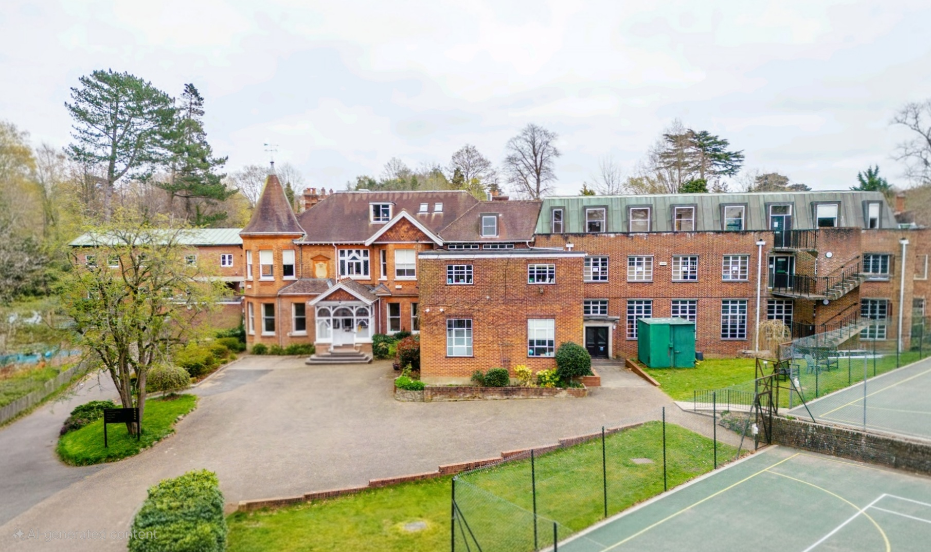



PROPOSAL OVERVIEW

Laurel HOUSE SCHOOL

School:

Position

Location
HEADTEACHER
Sevenoaks, Kent

EXECUTIVE SUMMARY

At Renaissance, we believe every child deserves an academic education that recognises their individuality, nurtures their potential, and supports their emotional and social development. Our journey began with a simple but powerful vision: to create safe, therapeutic, and nurturing learning environments where children and young people with special educational needs can truly thrive — not just emotionally, but academically, achieving success in line with their peers.
​
We want every child to leave our schools not only with qualifications, but with confidence, independence, and the skills to embrace life’s opportunities. A child’s future should never be limited by their needs — and we are here to ensure it isn’t.
​
We are proud of the work we’ve done so far — from our flagship school, Maple House in Birmingham, to our upcoming Willows School in Lincoln, with more schools planned over the next year. But this is just the beginning.
​
Our ambition is to become the leading SEND education provider in the UK. Not for recognition, but because we believe real change is needed — and we want to be part of that transformation. We are committed to:
- Opening more specialist schools across the country to meet growing demand for an academic-first approach in calm, therapeutic, and nurturing environments.
- Supporting families with compassion, honesty, transparency, and practical guidance.
- Building strong partnerships with local authorities to help shape meaningful reform in SEND provision.
- Delivering therapeutic, individualised education that puts the child at the centre of every decision.
- Ensuring year-round provision for children and families through meaningful partnerships with charities, community workers and specialist services — so that support doesn’t stop when the school term ends.
​
We understand the challenges families face and the journeys they’ve been on. We recognise the pressures schools and professionals are under. And we know that meaningful change takes time, collaboration, and courage. That’s why we’re here — to listen, to learn, and to lead with heart.
Thank you for being part of this journey. Whether you’re a parent, educator, professional, or advocate, we’re truly glad you’re here.

Together, we can build a future where every child feels seen, supported, and empowered.
​
Warmest regards,
Jawad
Proprietor/CEO
Renaissance Education Group.


CONTENTS

- Role
- School

- Candidate
- Application Process
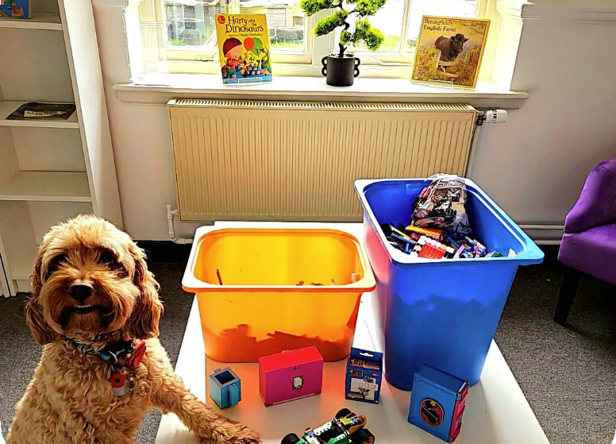

HEADTEACHER

Job Title: Headteacher
Reports to: Jayson Rawlings
Location: Sevenoaks, Kent
Hours of work: 40 hours per week, 39 weeks

THE SCHOOL

“Laurel House supports children’s growth through learning and therapies.”

Laurel House School is the next exciting new school for the Renaissance Education Group based in Sevenoaks in Ken.

Laurel House School holds a special place in the heart of Renaissance Education. Named in memory of a long-serving and much-loved member of staff, The Laurels—formerly known as Walthamstow Hall Junior School—will welcome its first pupils in 2026.
​
Set within 2.98 acres of picturesque, tree-lined grounds, the school offers a serene and spacious environment where children can thrive. The outdoor areas will feature dedicated spaces for horticulture, forest school activities, and social interaction, encouraging exploration and connection with nature.
​
Originally built in 1903, the school building has been thoughtfully adapted over the years, blending historic charm with modern functionality including a standalone music block, separate lodge and tennis courts.

The school is currently going under an exciting transformation bringing in specialist classrooms and facilities to offer children an academic first approach to education, in a caring and therapeutic environment built on a relational approach. The school will have dedicated spaces for Food Technology, Design Technology, Art, Science and Music, plus a dedicated multi-disciplinary clinical team and therapy spaces.

OVERVIEW

Laurel House School is a nurturing and ambitious independent special school for young people aged 5 to 19 with Autism Spectrum Conditions and associated social, emotional, and mental health needs. Our pupils may experience high levels of anxiety, trauma, self-harm, or restrictive eating disorders, and many have found mainstream education unsuitable.

We are proud to offer a safe, therapeutic, and academically focused environment tailored to the individual needs of each learner. Our curriculum spans a full academic pathway, enriched with vocational programmes, entry-level qualifications, and Functional Skills up to GCSE level. We also support students who are EBSA/EBSNA (emotionally based school avoidance/non-attendance), helping them re-engage with learning in a compassionate and structured setting.

This is a unique opportunity to lead a school that puts children first — where education is about more than qualifications; it’s about confidence, independence, and preparing for life.

THE IDEAL CANDIDATE WILL BE:

The following areas of experience are key to the role, and the candidate must be able to demonstrate they are able to work the Renaissance Education way.

- Previous experience as a Headteacher (may consider an amazing DHT)
- NPQH (desirable)
- Experience of working with SEND and SEMH children and young adults or in a mainstream setting with a genuine interest in learning about SEND.
- Leadership experience, able to provide leadership scenarios and examples of achievements.
- Working with stakeholders to include Governance and third-party organisations.
- Able to deliver against key school targets.
- Ability and ideally record of developing culture within a school.
- Capable of staff development and inspiring staff to make progress.
- Used to working with and managing school strategy to include knowledge of staff development and examples of success.
- Able to understand why the vision, values, plans for the school are so important to the forward plan/
- Demonstrate tenure and progress, through examples.
- Able to develop key partnerships to support the school.
- Understanding of grants and other financial support available to school/students.
- Capacity to lead from the front.
- Communicative, able to share ideas and create bigger pictures.
- In depth understanding of the value of relationships with staff, students and stakeholders.

Personal Attributes
- Great leader, quick to earn respect and motivate people to improve the work environment.
- Possess an organised and thorough approach to work and importantly able to manage.
- Strong professional image, generating immediate personal credibility.
- Strong work ethic and ability to work on own initiative.

Questions: -

How many students? | Up to 120  KS1 – KS5
SEND types/needs? | Autism Spectrum Conditions – ADHD, SEMH, Communication, PDA, Anxiety, Emotional Based School Avoidance (EBSA).
Leadership Hierarchy? | Headteacher, DHT, SLT.
Anticipated Challenges? | Setting the culture of a new growing school and ensuring teachers have the skills and passion to support children with SEND in a brand new school
Expectations? | Have a positive impact, embrace culture, ethos, be able to manage and develop staff.  Be able to model best practice and create an environment the Renaissance way
CPD? | A great CPD budget to support growth with additional new systems such as National College embedded already.
Support? | A central team to support with business functions and experienced line management
Salary & Benefits? | Starting at £84,699 (L21) with a clear pay and growth scale.
Development | Exciting time for the school group with a lot of opportunities for growth and development.
Why Laurel House School? | Because Renaissance Education is a brand new exciting company that puts the children first, it’s not about money, it is about their future.

APPLICATION PROCESS

BRIEF:
A full application pack is available on the website. Please ensure you complete all questions and the personal statement. This must include all previous job roles, responsibilities and experience with three references including your latest employer.
A full job description is available on the website and you can find more information at www.rests-sen.uk

SHORT LISTING:
We will actively target candidates who fit the agreed brief. These candidates are often currently employed and we understand that discretion is key. Following our short listing, we will invite you to interview and will send out our reference requests at this point.

SCREENING:
Candidates identified as a strong match for the position are pre-screened to assess their overall suitability for the role, alongside standard candidate qualification criteria e.g. salary requirements, locations, experience, qualifications, objective and soft reference.

1ST STAGE INTERVIEW:
Those candidates who progressed following a pre-screen will be invited to a competency-based interview with the New Schools Lead and a Renaissance Education Headteacher. This will also enable you to take a tour of the school.

DISCLOSURE:
Candidates invited to 1st Stage Interview are offered full school disclosure. This includes a full Job Description and a full School Overview in the form of a “candidate pack’’.

SHORTLISTING MEETING:
A final shortlist of candidates will be presented to the board and a further short list will be chosen. This shortlist includes full interview notes based on the key competencies identified in the Job and Person Specification. The board will then notify the successful candidates of the 2nd stage interview process.

INTERVIEWS:
The interview process will take place at the school and will include a presentation on the ‘why’ you want to be a headteacher at Laurel House School, and ‘How’ you will deliver the Renaissance Vision and an outstanding school that is fit for purpose and designed to include and engage all relevant stakeholders. There will also be a box task and chance to ask the board any questions.
This interview will assess school, role and cultural fit alongside deeper questioning to establish competencies and confirm an individual’s commitment to both the role and long-term future of the school.

OFFER:
We firmly believe that a personal approach should be managed effectively up to and beyond the point of offer. We accurately identify each candidate’s true salary expectations at the first point of contact and then manage those expectations throughout the recruitment phase. We are a new school with an exciting salary package and ongoing growth policy. As a company, we do not offer Teacher Pension Scheme, however, do provide a very competitive NEST based pension scheme and our salary offer ensures that this is considered and reflective.
Our robust processes allow us to say we will never make an offer to a candidate that will not be accepted.

BENEFITS:
- Excellent CPD and growth model
- Perkbox - for online discounts, rewards, health insurance, cycle to work scheme, free coffee and much more.
- Staff recognition awards
- Wellbeing and team days
- A school gym and showers
- Continual CPD and career development/training and mentoring
- Company Pension Scheme
- A warm, caring and exciting working environment that promotes kindness, respect and a safe place to work.
- £250 referral scheme bonus

COMPLIANCE:
All relevant candidates will be subject to pre-screening in line with KCSIE safer recruitment practice to include but
not limited to: -

- References
- Pay Scale Verification
- DBS
- Online Search
- Photo ID
- RTW
- Qualification Verification
- Training
- Medical Questionnaire

Starting at Laurel House School:
All staff will undergo a six-month probationary period. Upon successful completion, a performance management review will be conducted to establish clear first-year targets, ensuring the school is fully prepared for its initial inspection.

